Woodlands
Pupil Press

Croeso
Welcome to Woodlands Community Primary school Spring newsletter.
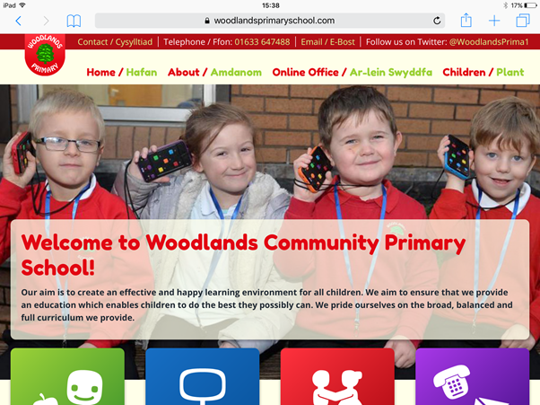
Super School Website!

The new, super school website was created during October 2017 by one of our teachers here in Woodlands , Miss Wey. Miss Wey is in charge of this website and you can access this at
www.woodandscommunityprimary.com , she can change anything on this supersite! “I love the school website because it looks very modern and up-to date, it’s very colourful and attractive. The website is useful for people looking for a new school for their child to come to. The website gives much information about the school and it can make a really good impression on people who want to join the school!” Gushed Miss Bates.
As a very succeeding school we feel it is important to have a website to boast about how amazing our school is and how talented all the pupils are in the school. You can see how pupils succeed in their clubs , the super website has links to other websites .e.g Mathletics, purple mash and Bug club.There are attendance results posted and you can find out what your children have been doing this term. In addition to this You have access to the school dinner menus for both Cold and Hot dinners. It allows all people to see what the school has been doing all term and the work we have been succeeding in.

World Book Day
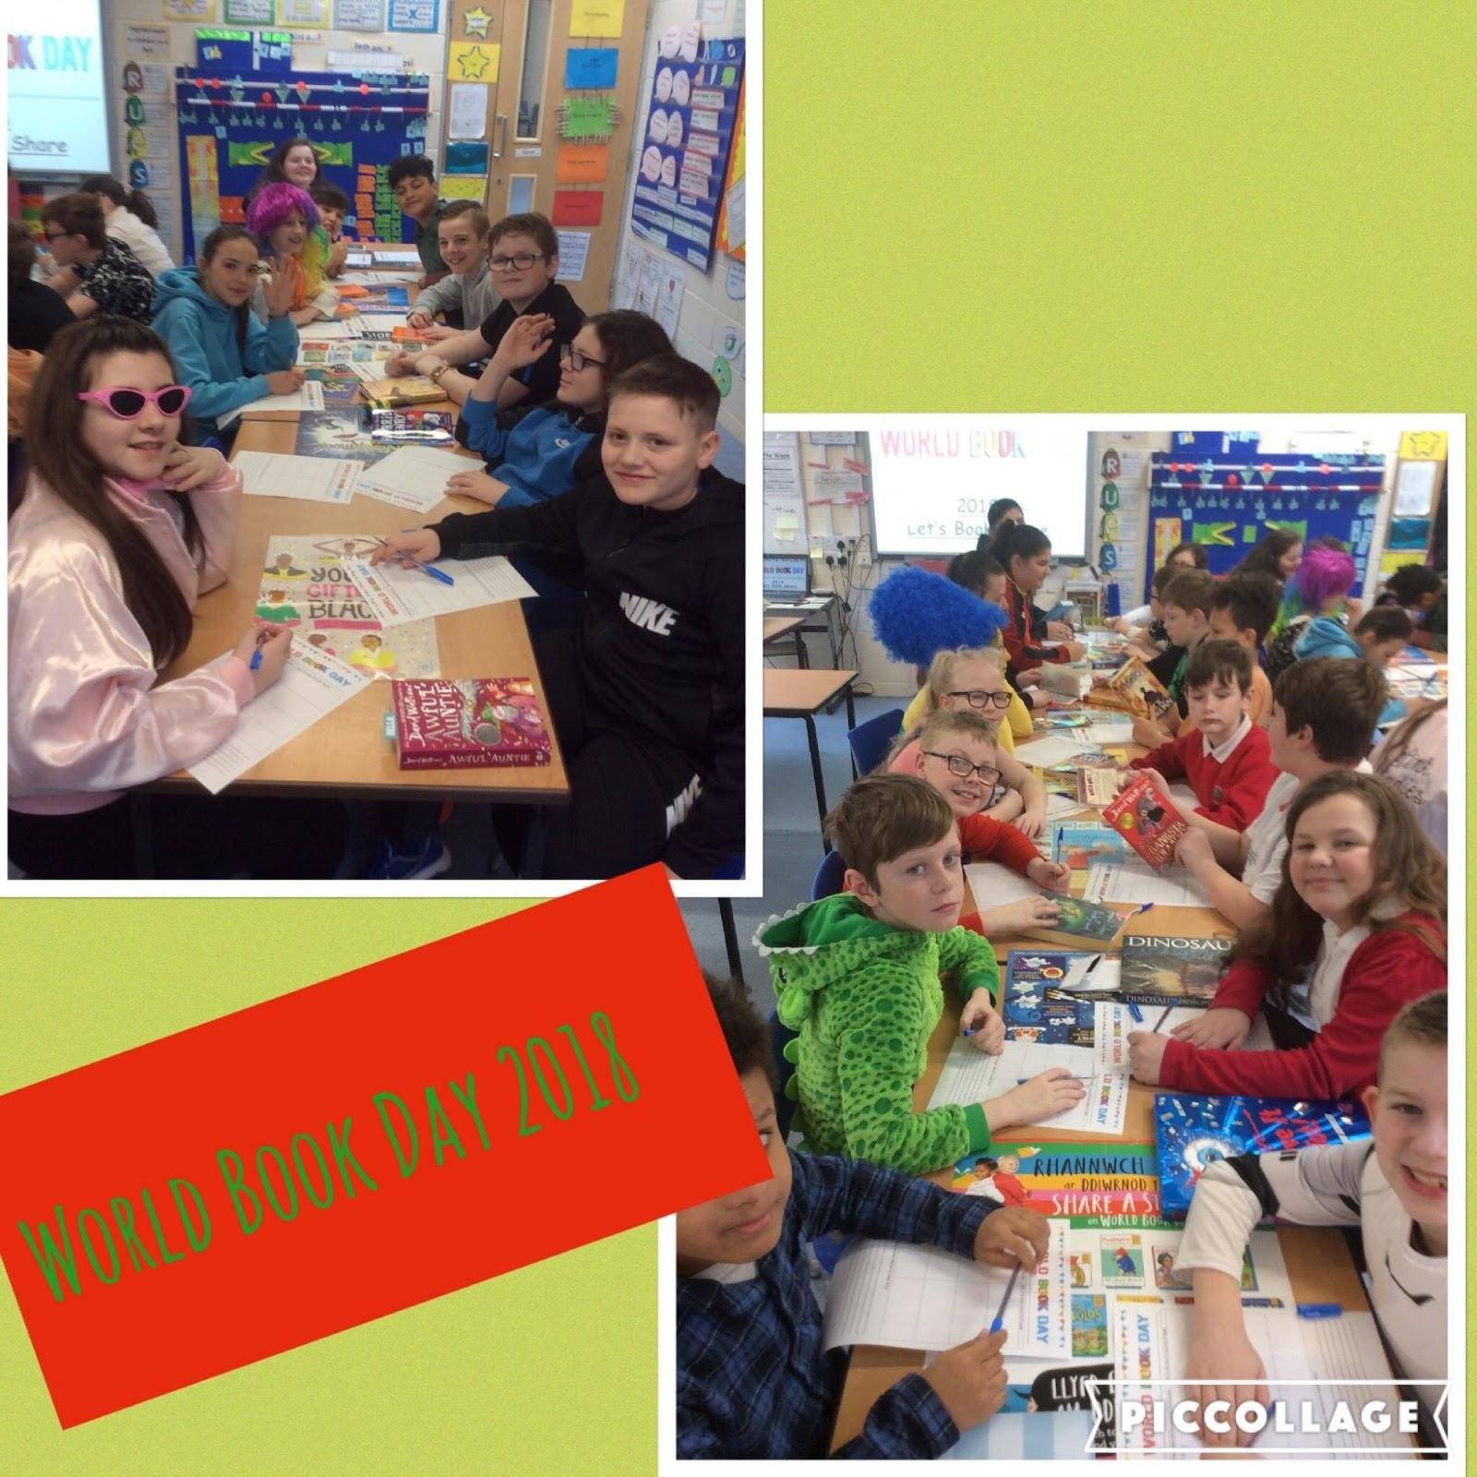
World book day was on Thursday 1st March, on this day people dressed up as their favourite characters from their favourite books. At Woodlands on World Book Day two people from each class were chosen for the best costume and they received a prize from their teacher. Melis Ilaslaner reported “ I loved world book day because it is a good day to show how much children like to read books”. During the day children from every class sat in a line and waited to be called up to show their WONDERFUL costumes! The winners had photographs taken and received a book as a prize. However, everyone else still had their photograph taken in their remarkable costumes too. The purpose of world book day is a celebration of authors, illustrators and books. Some ideas that we had were Matilda,Mr Stink,Maleficent and Mrs Twit. The whole school took part in book activities throughout the day. Mrs Coopers class enjoyed, “speed dating” where they were timed and told each other about their favourite book.

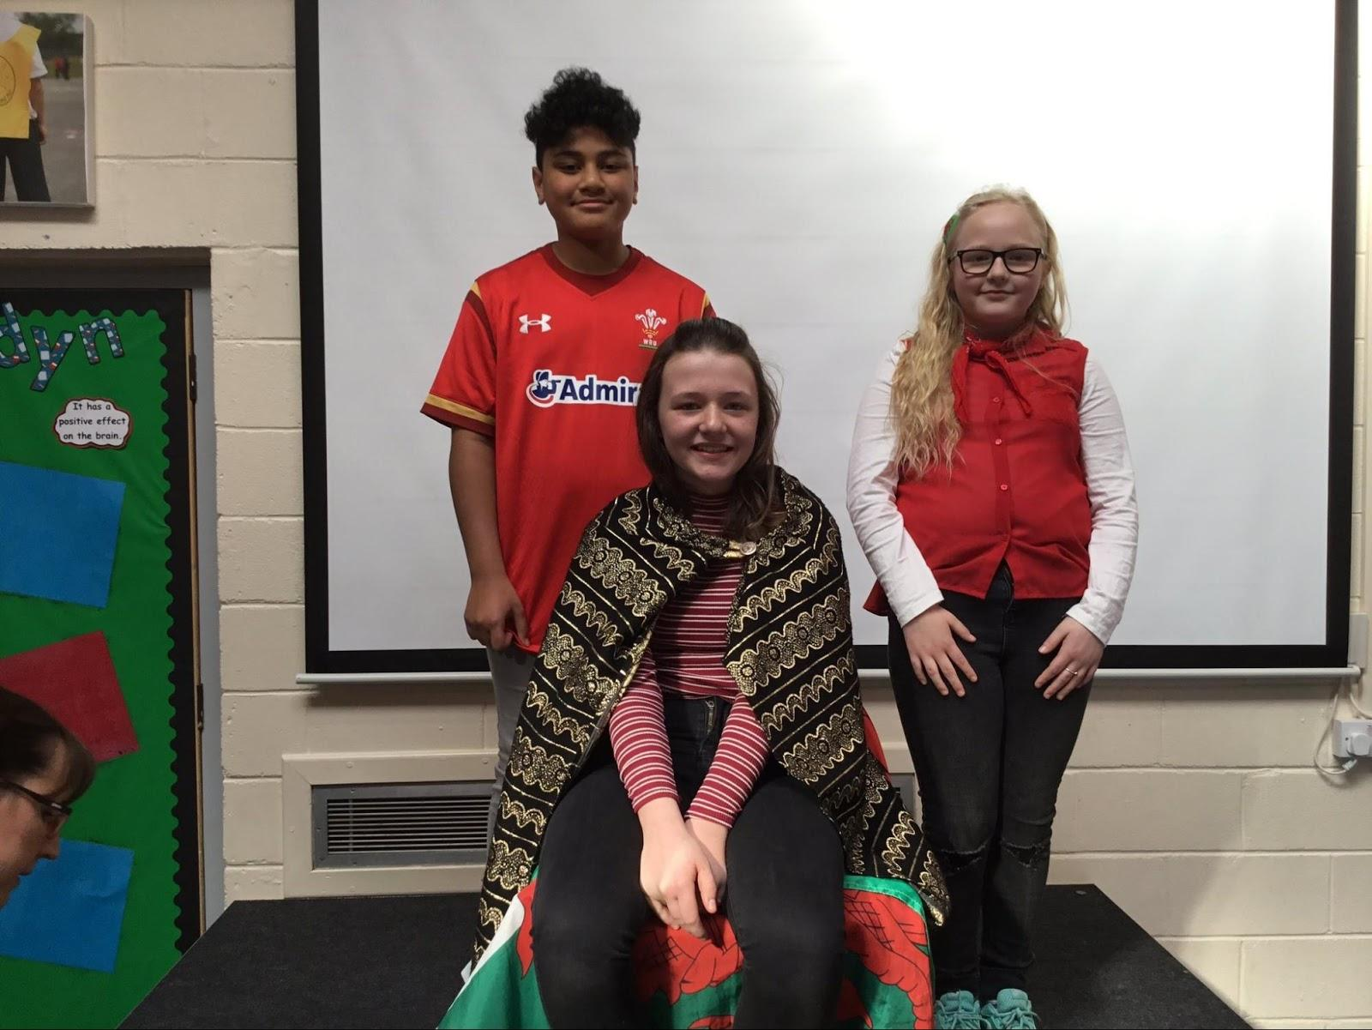
Eisteddfod
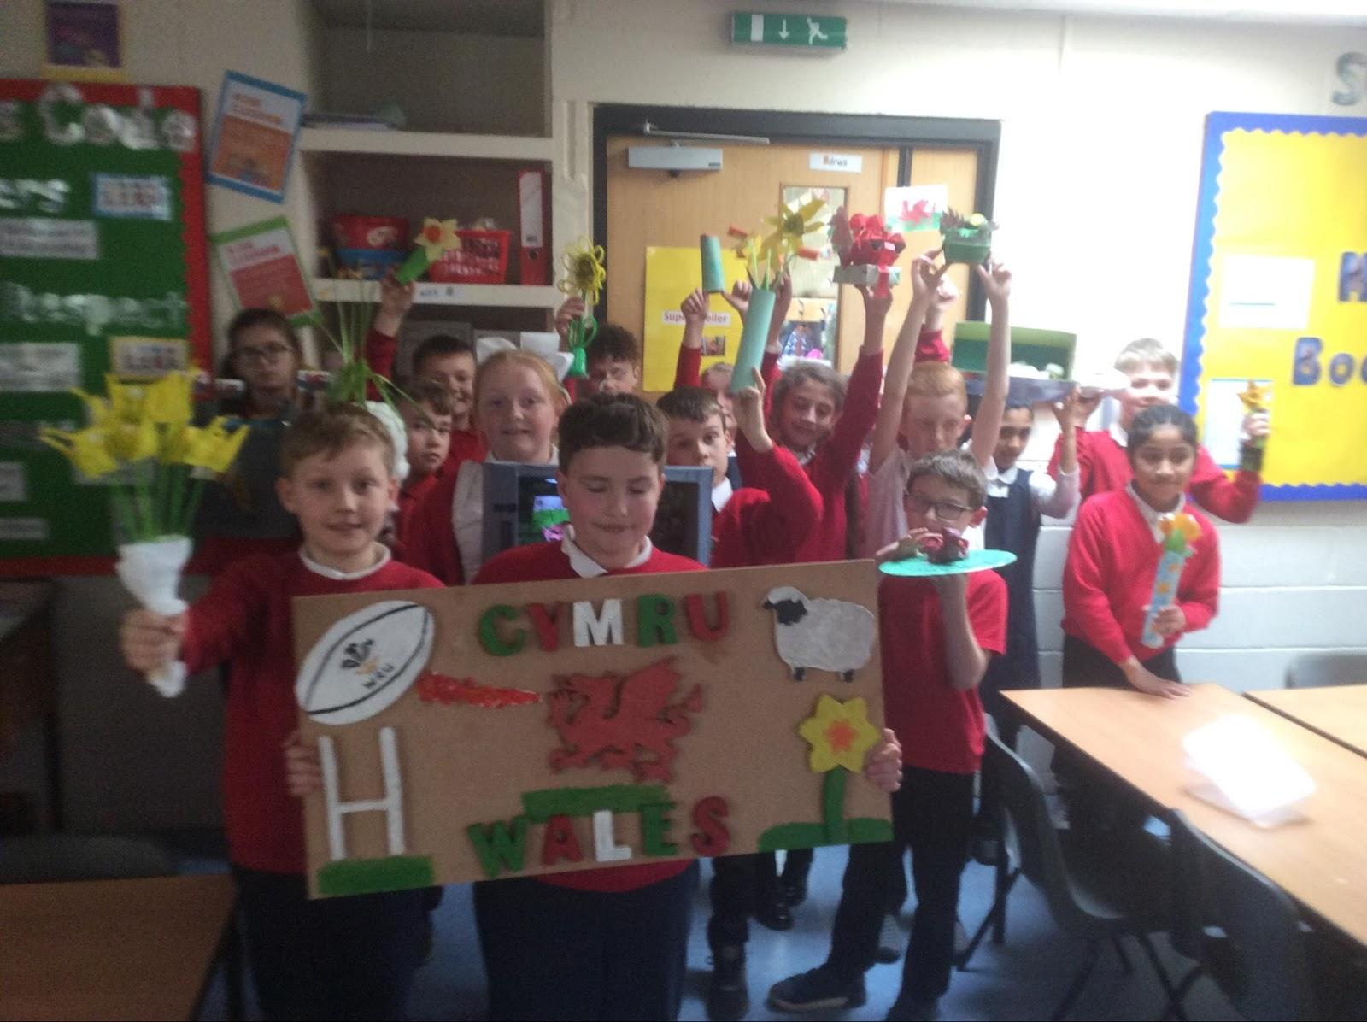
This year our Eisteddfod was rearranged due to an unexpected snowfall. However, it was still a great success. Eisteddfods are celebrated in schools throughout Wales every year to celebrate Welsh culture. At Woodlands we feel that this is a very important day in our calendar because it allows us to celebrate our welsh heritage and to be proud of our culture. Miss Cook quoted, “Every year we hold an Eisteddfod during the first week of March to celebrate Welsh culture.This is a Welsh festival of literature and music, with each class having the opportunity to perform in front of the whole school and our governors.The Eisteddfod comes to a close with the crowning of the Bard before the whole school join together to sing our National Anthem.” Here at Woodlands Community Primary school we held class competitions,each class had a different theme . We showcased our welsh models and art work that we made at home or in school. In year 6 the pupils took part in a poetry competition.Their Poems were inspired by Dragons and the Welsh Culture. The winning poets were then sat on a chair, on a stage, and a sword was lowered over their heads to represent the crowning of the Bard. Many prizes were given to winners in every class of the school. Miss Grainger’s class sang a song,this song was called Sosban Fach. Mrs Gratton’s class made models for homework that were objects or symbols from Wales,Mrs Cooper’s class did a Welsh poem for the school to hear.On the day of the Eisteddfod, students were allowed to wear Welsh clothing. Some suggestions of traditional clothing that were worn in this years Eisteddfod were, the Welsh lady,the Welsh miner and the Rugby player.

Football

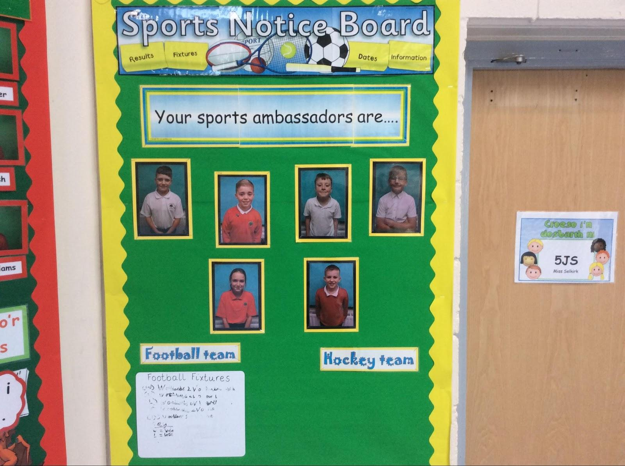
On Monday 17th April in Cwmbran Stadium a football match took place with many schools such as our amazing school, Woodlands Primary. The children
that went were Joshua Groves, Cyan Bailey, Ashton Strange, Nathan Pinch, Jayden Hailey, Cohen Thomas, James Talami and Ryan Wojtowicz. Nathan Pinch quoted, “I was glad we went and we never gave up, even when things didn't go right.” The tournament didn't go as well as they would have wanted it to but they still carried on regardless . Miss Grainger reported, “The boys showed excellent sportsmanship, and didn't give up even when the score didn't go their way.The boys came back to school full of themselves and not upset with their score.Our school is proud of everyone who went whatever the score. What matters is that they tried their hardest and took part in it with pride”.

STEM
This term our school held its very first STEM competition. In order to take part in STEM, we had to make a floatation device and hand it in to Miss Grainger or Miss Morgan. We had to show evidence of how we made it by creating a labeled diagram of how it was made. We also had to show a list of what went well and what didn't go well. Miss Grainger quoted, “ I would like more children in our school to be inspired to want to have a job in the
Future of science,technology,engineering or maths and for Woodlands children to enjoy solving problems and being inventive.”
The entries for STEM had to be handed in by the 26th of February 2018. STEM is a organisation which specialises in science,technology, engineering and maths,this is what STEM stands for. We had a talk in a special assembly with some people from STEM ,they taught us that our gender should not hold us back and women can become engineers too.This inspired all the children in Woodlands and helped us to believe that we can be whatever we want to be. We are really looking forward to the next STEM competition and to develop STEM in Woodlands in the future.

Written by: Maddison Arscott, Mikka Todd, Nancy-May James, Lily-Mae Devlin, Seren Herbert, Kian Bradley, Catrin Herbert, Taya Wilkinson, Trystan Hurley, Aaron Fincham, Caleb `Smith and the one and only Mrs Gratton.

