Woodlands
Pupil Press

Croeso
Croeso and welcome to the Summer term newsletter. This newsletter was created by the talented pupils of Newsletter Club and, also the one and only Mrs Gratton. This newsletter will inform you of everything that has been happening during the Juniors Summer term. We hope you, enjoy the newsletter!

Entrepreneur
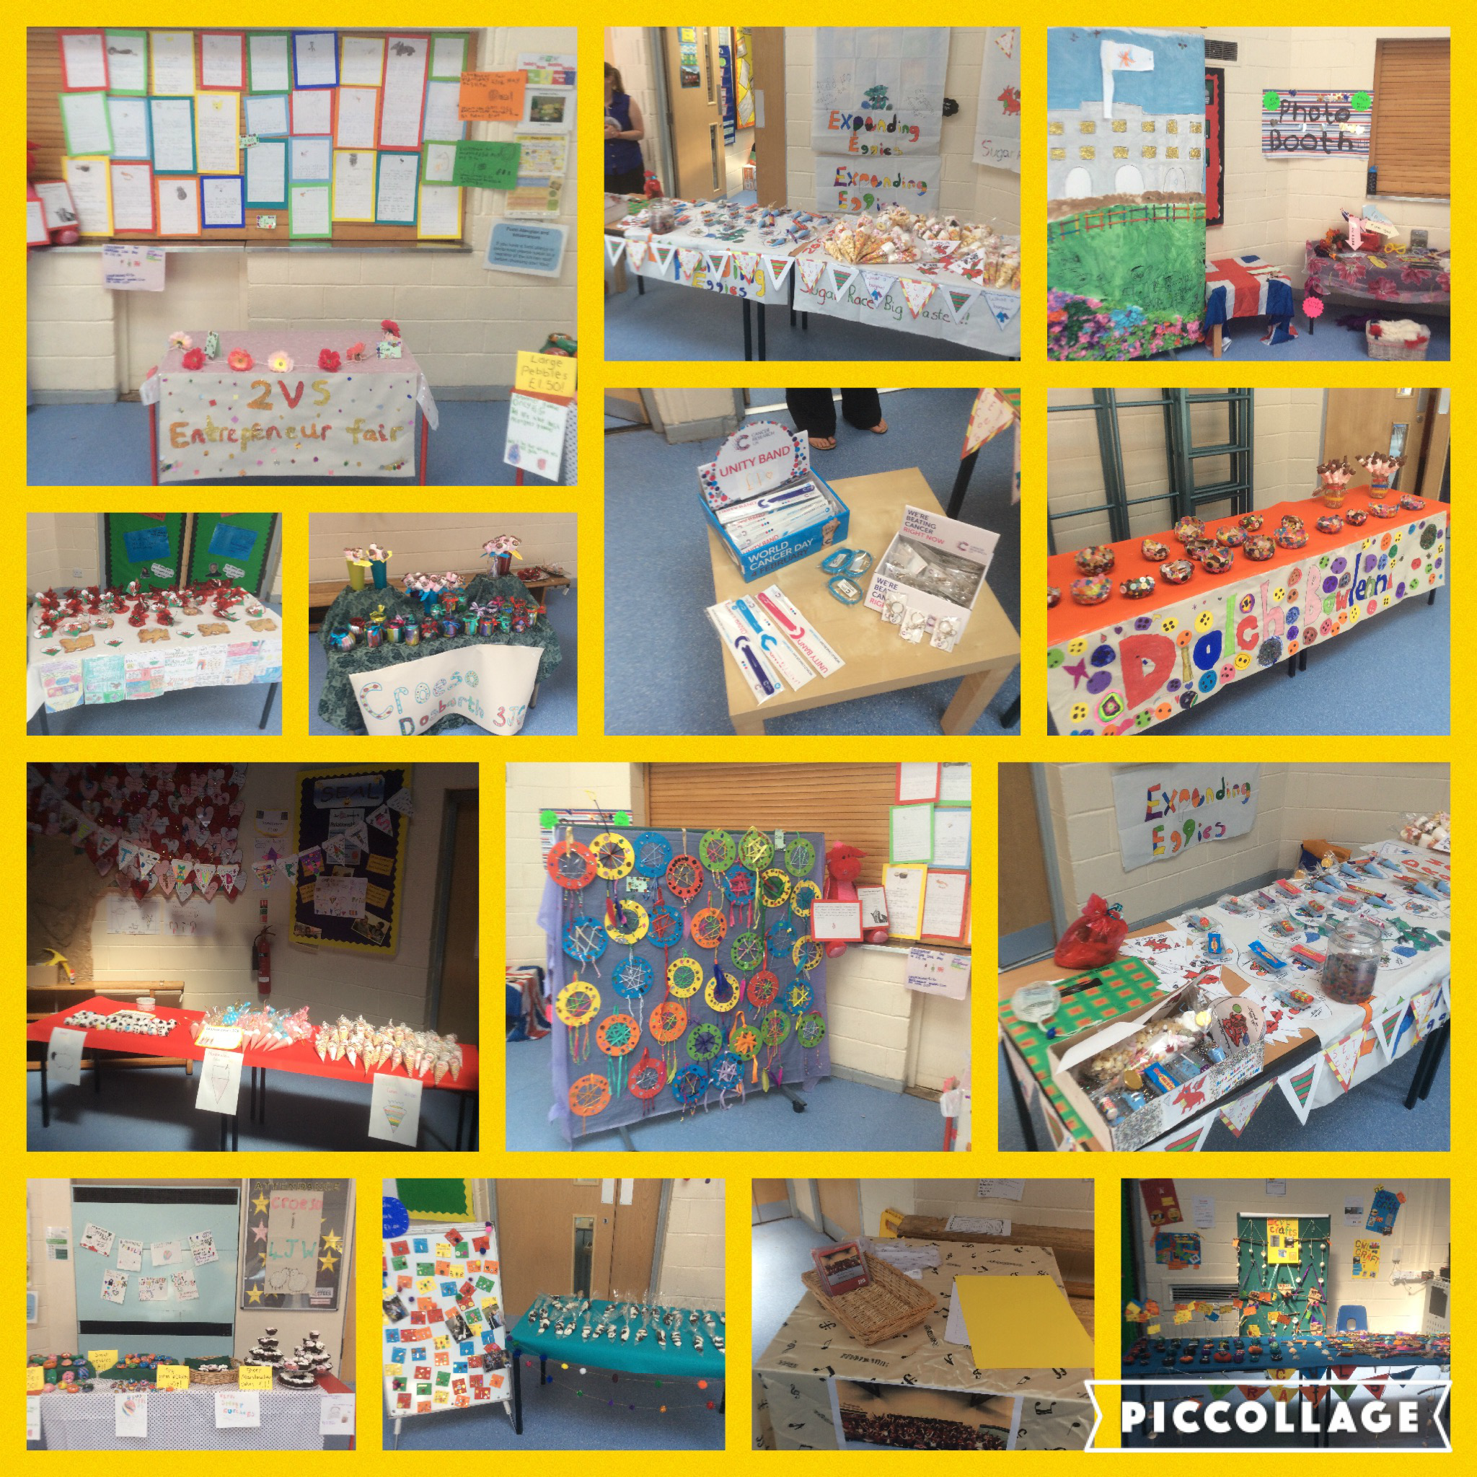
On the 23rd of May 2018 we held entrepreneur , the fair was held in the junior hall. Entrepreneur is a day where children try to raise money for their classes by selling things they made during the week, they had to make and sell their merchandise. Pupils parents and family members came and bought various things from the fair, The class with the most profit raised was Miss Wey’s with a huge profit margin of £141. Every class tried their hardest to raise as much money as possible by creating banners and having enthusiastic sellers! Even though Miss Wey’s class raised the most money, everyone tried equally as hard. We also had a welsh theme for some of our products and some stalls even had a welsh name, such as Miss Grainger’s stall called Cwl Crafts. Some of the welsh merchandise included

- Sheep Keyrings
- Royal Wedding Photobooth and
- Welsh Cupcakes
Entrepreneur was such an amazing experience and every pupil enjoyed it thoroughly!

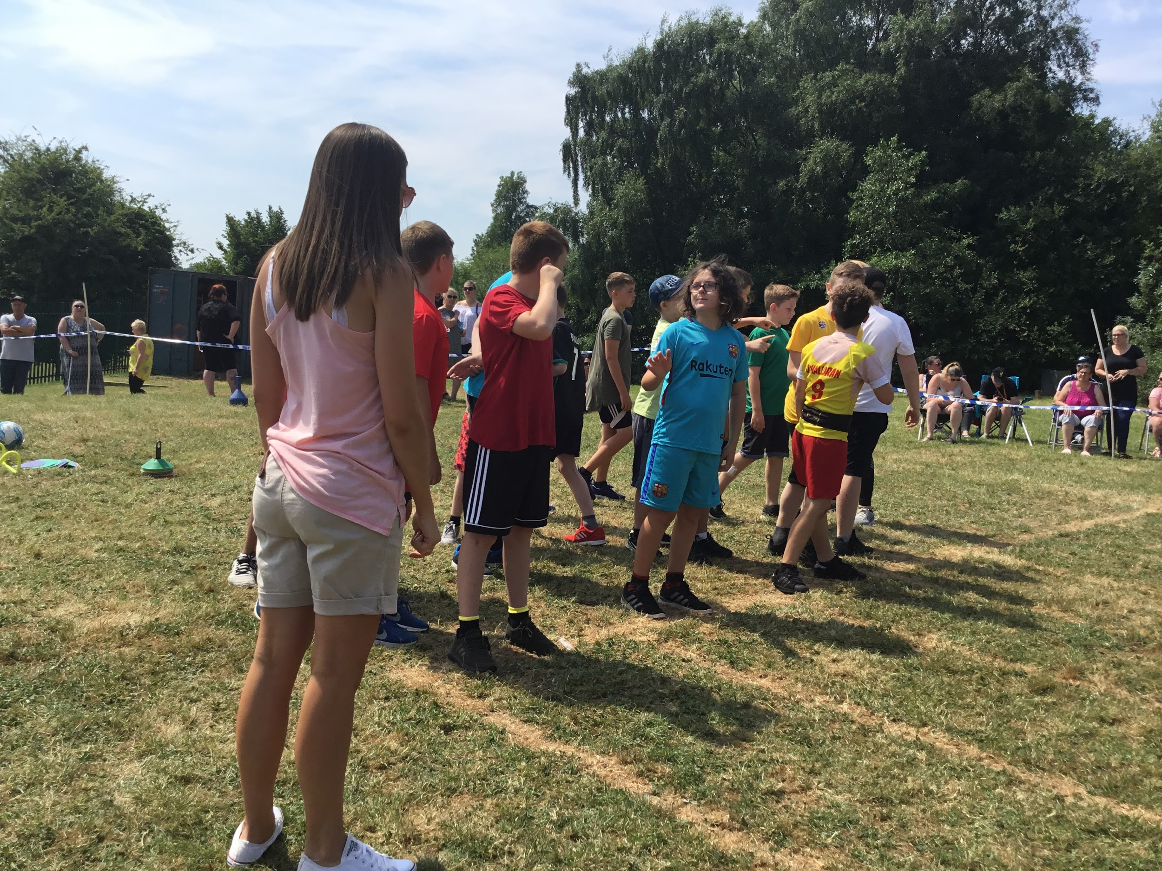
Sports day
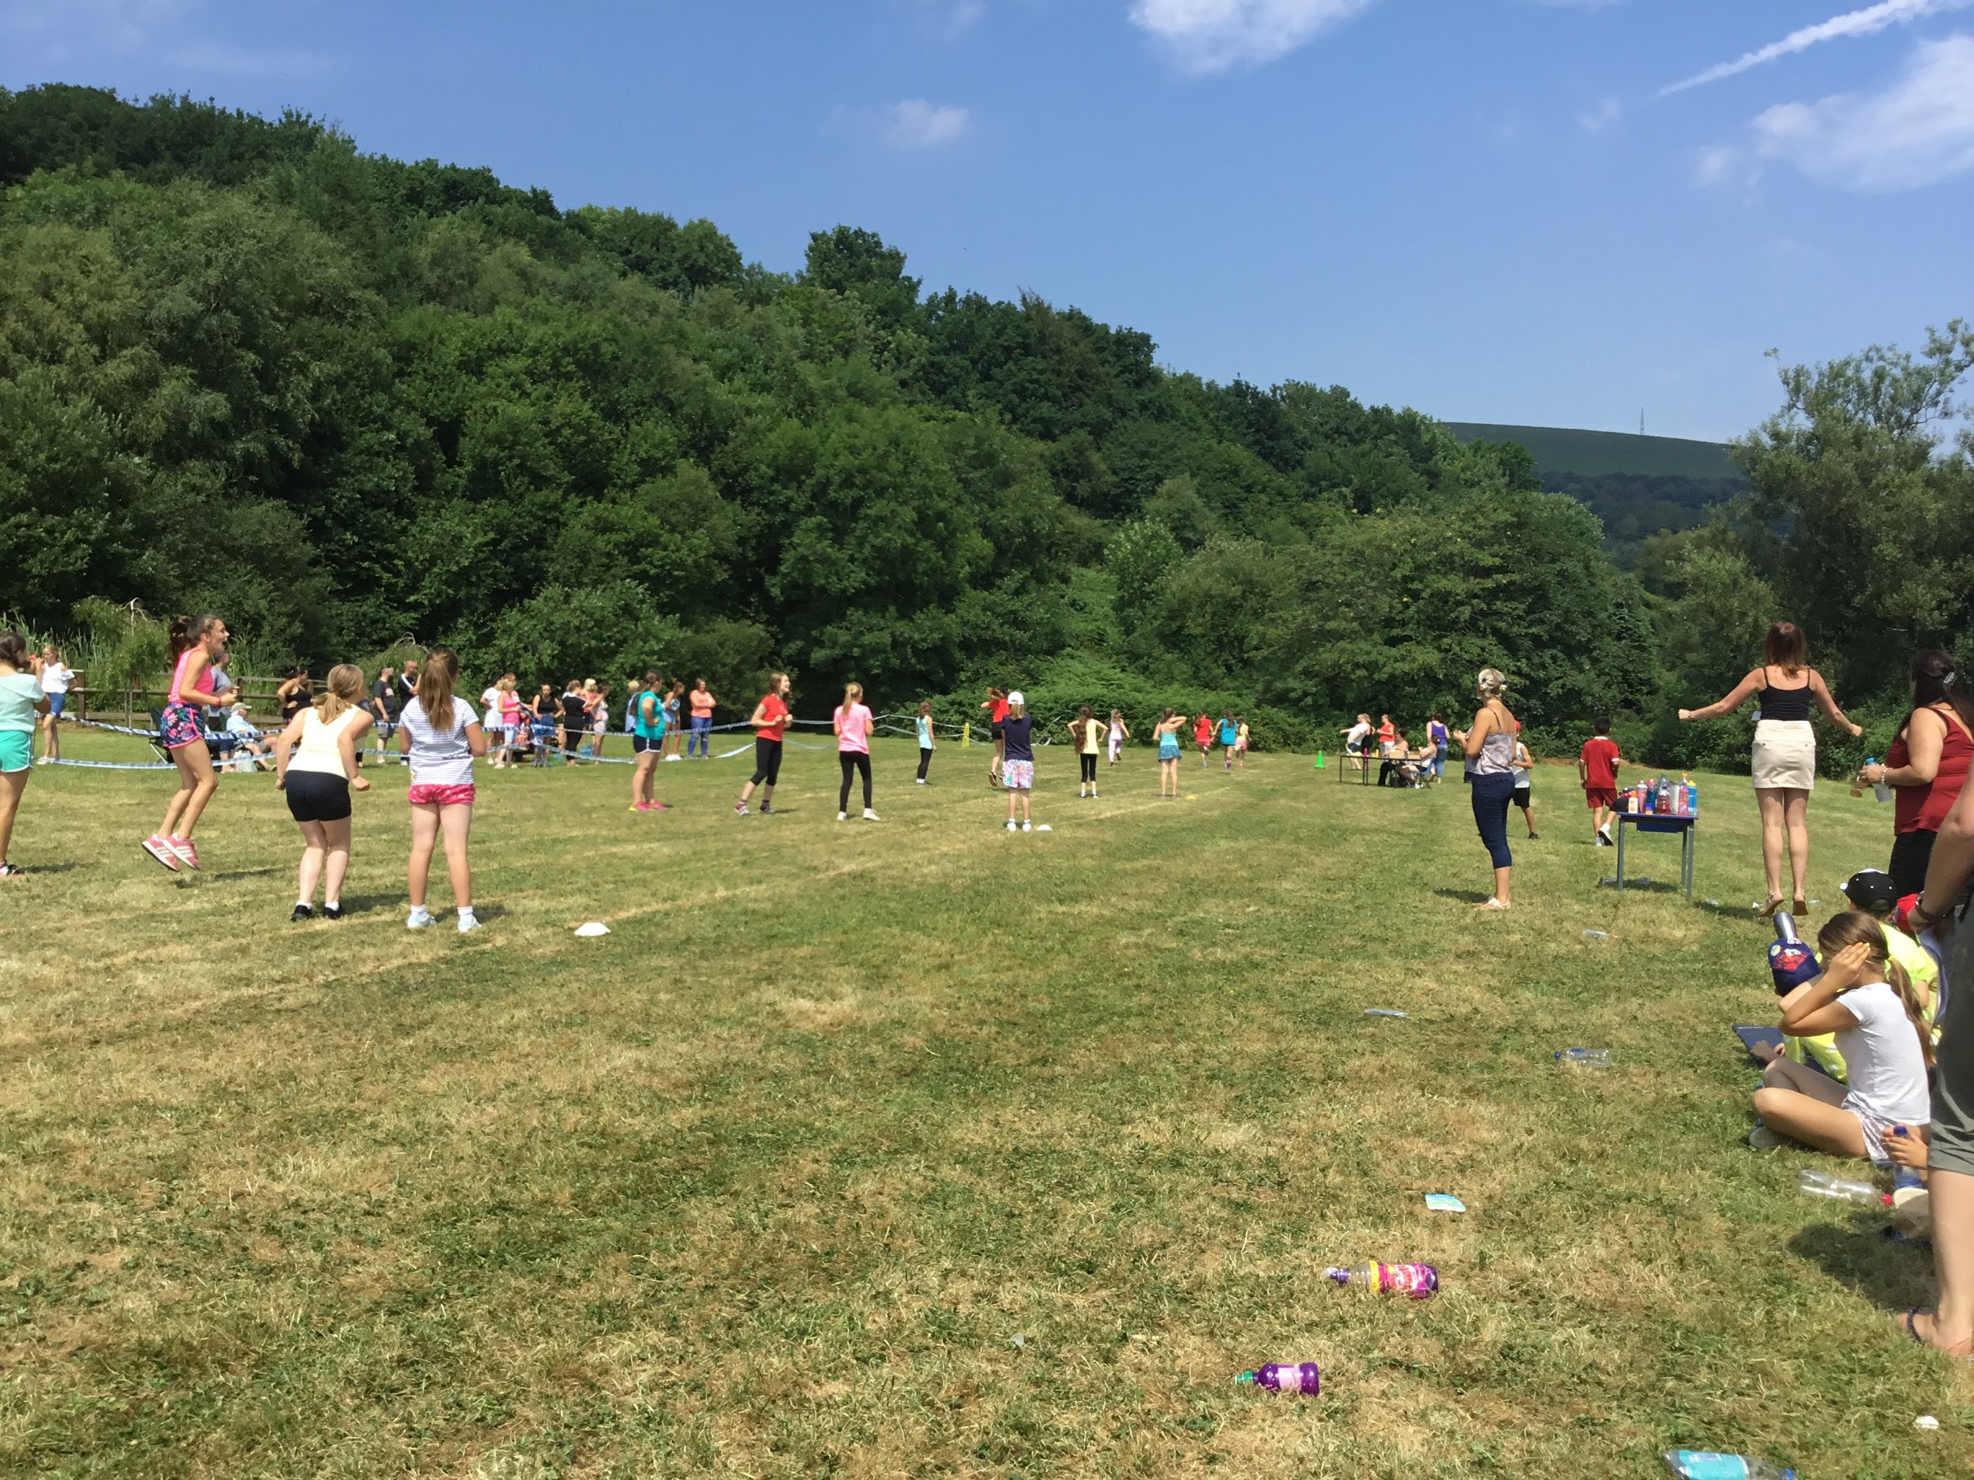
On the 9th July KS2 took part in sports day. Pupils in every class had a week before sports day to practise and learn different events. The sport events took place up on the field, parents came up to watch their children take place in the events.

The activities that we did this year!

- Relay race
- Running race
- Egg and spoon
- Obstacle course
- Skipping
- Beanbag balance race
The children were put in different coloured teams to participate in the events. This year’s results were as followed, melyn won, coch 2nd place gwyrdd 3rd place and glas 4th position. Children that took part thoroughly enjoyed sports day and displayed excellent sportsmanship.

Talybont
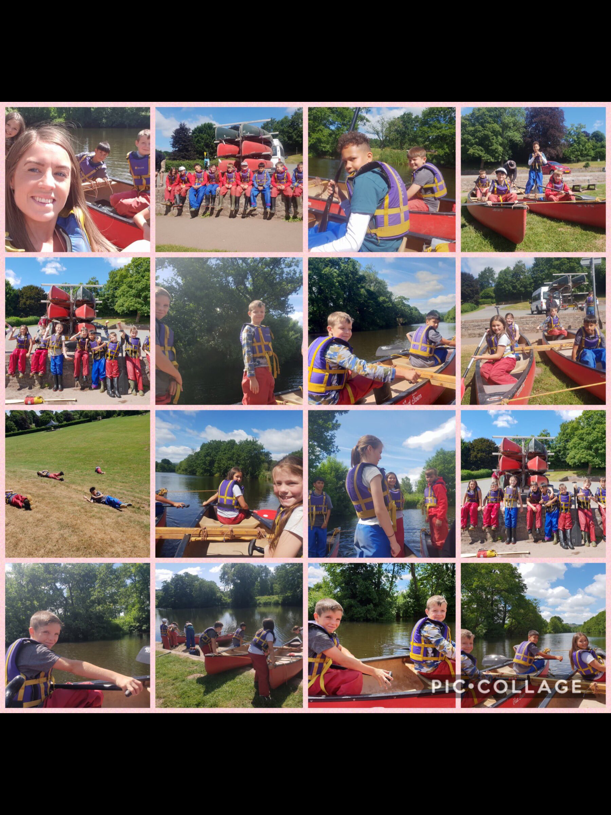
The pupils of year 5 and 6 were given an opportunity to go to Talybont, Talybont-on-Usk is a village and community in Powys, Wales. It lies on both the River Caerfanell and the Monmouthshire and Brecon Canal. During Woodlands visit to Talybont the Y5 and Y6 children had a fantastic time. During the trip the children engaged in lots of fun activities such as, problem solving, shelter building, canoeing and team building. The trip even taught the children to be independent and make their own lunch and clean their own rooms!

